- Download the zip file or pull the folder
- Go to chrome://extensions/ and Select Developer mode
Click on Load Unpacked
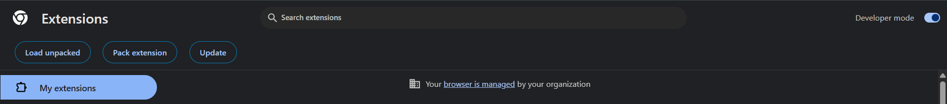
- Then Locate the folder and add as chrome extensions
- Open the extension .
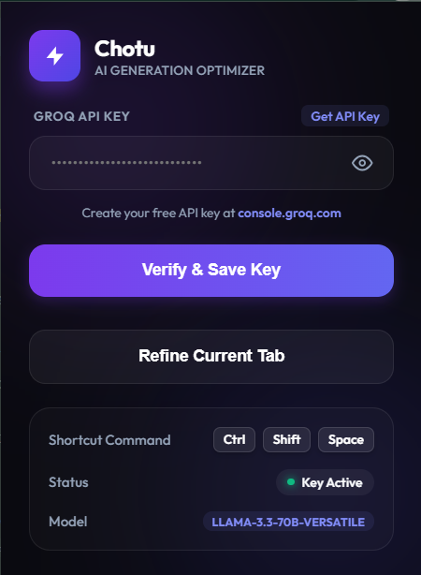
- Free api key is available in https://console.groq.com/keys. Create one of your own
- Paste & save your api key
- Go to any ai , chatgpt , claude , gemini , grok and type the task you wish to do in short
- Click ctrl+shift+space and u get ur refined prompt

